CCA - 1 Project Report
On
Code-mixed Ayurveda
Submitted to: Dr. Suja Panicker
Submitted By:
Tanmay Saxena - 1032233295
Saatvik Madan - 103223398
KS Arjun - 1032232286
ABSTRACT
Ayurveda contains a vast amount of medical knowledge that includes medicinal plants, drugs, diseases, formulations, symptoms, and therapies. But much of this knowledge is written in a multilingual and code-mixed manner wherein one sentence can contain Hindi, Sanskrit, and English. This kind of variability in text introduces difficulties for Natural Language Processing (NLP) especially in Named Entity Recognition (NER) task. Because most conventional methods might not be able to detect domain-specific Ayurvedic terminology, transliterations and code-mixed text. This project concentrates on Code-Mixed Ayurveda Named Entity Recognition wherein the goal is to explore NLP techniques for extraction of Ayurvedic entities from multilingual and code-mixed text. Different methods have been explored over various Ayurveda resources which include pre-trained biomedical NER models for English translation of Ayurveda pharmacological text, multilingual transformer models for question classification in Hindi Ayurveda, domain adaptation of Sanskrit language models using Ayurveda text resources and traditional methods such as TF-IDF with Logistic Regression as baselines. This project includes exploration of corpus, preprocessing, implementing the models, analyzing the results and comparing various methods used in the research.
1 INTRODUCTION
The field of Ayurveda includes vast amounts of medical information about diseases, medicinal plants, drugs, therapy procedures, etc. Owing to the development of digital technologies, the data on Ayurveda are communicated in code-mixed language that is the combination of words from Hindi, Sanskrit, and English languages within one sentence. As far as code-mixed texts may involve some variations in languages used, spellings, transliterations, and grammar constructions, it creates difficulties in recognizing named entities for the Natural Language Processing (NLP) systems since Ayurvedic terminology can be rather domain specific.
Code-Mixed Ayurveda Named Entity Recognition (NER) is designed to automatically recognize and classify the important entities from code-mixed Ayurvedic text. The examples of these entities may include medicinal plants, drugs, diseases, symptoms, formulations, etc. The purpose of the project is to investigate the NLP methods for processing of Ayurvedic text. These methods include the biomedical NER with pre-trained biomedical models, the multilingual transformer-based classification model, the traditional machine-learning baselines, and the adaptation of Sanskrit language models to the Ayurveda domain.
2.1 Research Question
Tanmay Saxena- To test the efficiency of the already trained model for detecting CHEMICAL and DISEASE entities in the translated Ayurveda pharmacological text from Charak Samhita-Kalpasthana corpus into English and then comparing this detection efficiency with the detection efficiency of Western biomedical texts.
Saatvik Madan- Is it possible for a pretrained multilingual transformer XLM-RoBERTa to successfully classify the Hindi language Ayurveda questions into their corresponding Ayurvedic categories, and is this approach better than the baseline approach of TF-IDF & Logistic regression?
Ks Arjun - Current models for Sanskrit language have been trained on generic Sanskrit text data and might fail to represent the linguistic nuances specific to the field of Ayurveda. Hence, the proposed work intends to tailor a generic Sanskrit language model for Ayurvedic Sanskrit with the help of HingAyur corpus.
2.2 Research Contribution
Tanmay Saxena- The significance of this research paper is that it offers an experimental assessment of the use of a trained Western biomedical named entity recognition model in translated Ayurveda-based pharmacological literature. This is achieved through the examination of entity detection performance, entity density, entity types, and patterns of detection within the Kalpasthana corpus and in comparison with a western biomedical dataset.
Saatvik Madan- This paper provides an analysis for a Hindi Ayurveda text classification pipeline utilizing the BhashaBench-Ayur dataset. A conventional classification approach such as the TF-IDF and Logistic Regression model is taken as a benchmark and is compared against the pretrained multilingual transformer called XLM-RoBERTa. The evaluation of these models is done through various classification metrics and visualization to check the efficacy of contextual multilingual representations.
Ks Arjun - In this research, the domain adaptation of the pre-trained SanskritBERT for the Ayurvedic Sanskrit domain is performed using the HIngAyur dataset. The innovation in this research is the exploration of whether the use of domain-specific texts would help in improving the masked-token prediction and language modeling ability of the model.
2.3 Methodology
Tanmay Saxena- The experiment starts with the preparation stage where Charak Samhita dataset is loaded, and the Kalpasthana part is selected from the dataset. The JSON objects are then transformed into a structured DataFrame and some basic statistics for the texts are generated. The next step is using the pretrained scispaCy en_ner_bc5cdr_md model to detect CHEMICAL and DISEASE entities in the texts. The same model is used on the set of 60 sentences from the Western biomedical literature, and then the results are compared.
Saatvik Madan- A supervised multi-class text classification technique has been employed in this research. The extraction of questions regarding Hindi Ayurveda from the BhashaBench-Ayur corpus has been followed by preprocessing and then splitting them into
training and test sets. TF-IDF + Logistic Regression has been adopted for the baseline, whereas XLM-RoBERTa has been fine-tuned on the Hindi Ayurveda questions. Performance evaluation has been carried out with the help of accuracy, precision, recall, and F1-score, along with confusion matrix analysis, etc.
Ks Arjun - The experiment implements domain adaptation on the pre-trained tanuj437/SanskritBERT model utilizing the HIngAyura Ayurvedic Sanskrit corpus. The corpus is first preprocessed to generate text chunks that are analyzed to extract statistical information as well as tokenization statistics before being split into train and validation datasets. SanskritBERT is then fine-tuned through masked language modeling for three epochs. Train and validation losses are recorded, and both the base and the fine-tuned model are compared based on validation loss, perplexity, and masked token prediction accuracy.
2.4 Description of Corpora
Tanmay Saxena- In the present work, the English version of the Ayurveda corpus based on Charak Samhita-Kalpasthana is used together with the Western biomedical corpus as a benchmark. The Ayurveda corpus symbolizes traditional pharmacological terminologies, whereas the Western biomedical corpus represents standard biomedical terminologies, where the same pretrained NER model is being analyzed in both domains.
Properties | Ayurvedic Corpus | Western Biomedical  Reference
Corpus name | Charak Samhita – Kalpasthana | Western Biomedical  Reference Set
Language used by model | English translation | English
Source | Gita/Datasets GitHub repository | Researcher-constructed
Number of entries | 13,201 verse | 60 sentences
NER model | en_ner_bc5cdr_md | en_ner_bc5cdr_md

Corpus URL: Gita/Datasets GitHub repository
Kalpasthana directory: Charak Samhita – Kalpasthana
Saatvik Madan- The text corpus that is used in this study is BhashaBench-Ayur. BhashaBench-Ayur is a benchmarking dataset based on Ayurveda which is created by BharatGen. This dataset includes Ayurveda related questions in Hindi and English language in different domains of Ayurveda. In this study, the dataset in Hindi language in Devanagari script is used for multi-class text classification.
Ks Arjun- HingAyur is the Ayurvedic Sanskrit text dataset used for domain adaptation of the pretrained Sanskrit language model. The HIngAyur dataset has been extracted from the digital text of the Carakasaṃhitā available from the SARIT (Search and Retrieval of Indic Texts) website that provides specific vocabulary, terminology, and linguistic features of the Ayurvedic domain. In the current experiment, the HIngAyur corpus consists of 115,124 words and 1,722,217 characters, which are split into 231 text fragments.
2.4.1 Corpus Exploration
Tanmay Saxena-The Ayurveda text corpus was analyzed by using basic linguistic and statistical parameters such as length of entries, POS tagging, and medical term frequency.
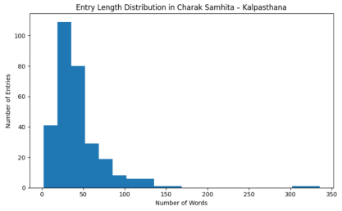Figure 1 — Entry Length Distribution
Shows the distribution of word counts across entries in the corpus
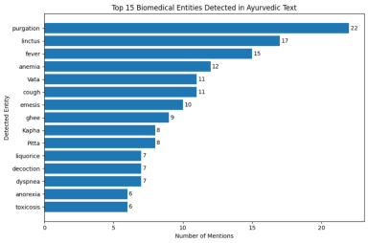Figure 2 — Top 15 Biomedical Entities Shows the fifteen biomedical entities most frequently detected by the pretrained NER model in the Ayurvedic text
Saatvik Madan
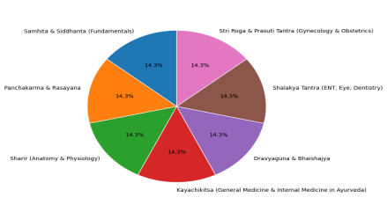Figure 3. Ayurveda Domain
Distribution of Hindi questions across the selected Ayurvedic domains.
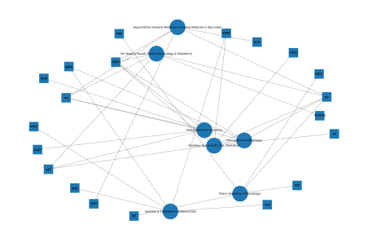Figure 4. Stopword Analysis
Characteristics of the Hindi questions, including word-frequency or question-length patterns.
Ks Arjun -
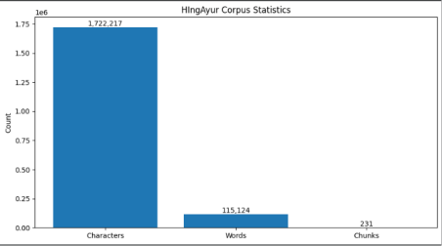Figure 5: HIngAyur Corpus Statistics
The HingAyur corpus contains approximately 1,722,217 characters, 115,124 words and 231 chunks.
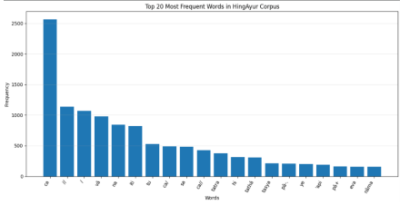Figure 6: Top 20 Most Frequent Words in the HIngAyur Corpus
The frequency distribution shows the 20 most frequently occurring tokens in the corpus.
2.5 Implementation
Tanmay Saxena- The experiment was carried out using Python language where we used pandas for processing the corpora, spaCy/scispaCy for natural language processing and biomedical named entity recognition, and Matplotlib for visualization purposes. Pretrained en_ner_bc5cdr_md model was used without any further training or fine-tuning, and its predicted entities of type CHEMICAL and DISEASE were counted.
Saatvik Madan- The approach relies on XLM-RoBERTa (xlm-roberta-base) model, which is a pretrained multilingual transformer from Hugging Face. The questions in Hindi language about Ayurveda are encoded using XLM-R tokenizer and then fed into the transformer for fine-tuning on a supervised manner. A classification layer is learned for predicting Ayurveda domain in the question. For the sake of creating a baseline model, the TF-IDF extraction of features followed by a logistic regression model is developed.
Ks Arjun - The implementation was done in Python with the help of Hugging Face Transformers and Datasets libraries. The HIngAyur corpus was partitioned into training and validation sets and then tokenized by means of the tokenizer corresponding to SanskritBERT. The pretrained SanskritBERT (tanuj437/SanskritBERT) was fine-tuned with masked language modeling for 3 epochs on the dataset. Training and validation loss were tracked and plotted, and comparison of the base and fine-tuned models was performed based on validation loss, perplexity, and prediction accuracy.
2.6 Results
Tanmay Saxena- Performance assessment of the NER model was conducted based on detection rate, entity density, distribution of entity types, and correlation between text length and entity detection. Due to the lack of a gold standard entity annotation in the corpus, accuracy, precision, recall, F1 score, and confusion matrix were not used for assessment purposes.
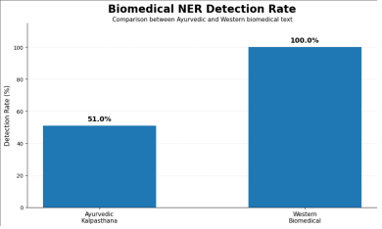Figure 7: Biomedical NER Detection Rate
Compare the percentage of entries containing at least one detected biomedical entity, with 51.0% for Ayurvedic text and 100.0% for Western biomedical text.
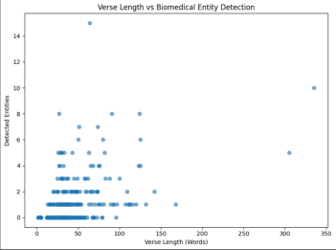 Figure 8: Verse Length vs Biomedical Entity Detection
Shows the relationship between verse length and the number of biomedical entities detected by the NER model. 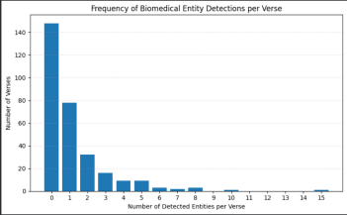
Figure 9: Frequency of Biomedical Entity Detections per Verse
Shows how frequently different numbers of biomedical entities are detected within individual Ayurvedic verses. 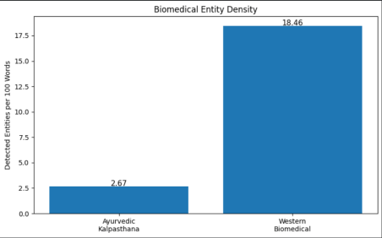Figure 10: Biomedical Entity Density
Compares the number of detected biomedical entities per 100 words in the Ayurvedic and Western biomedical texts.
Figure 11: Biomedical Entity Type Distribution Across Corpora
Compares the normalized distribution of CHEMICAL and DISEASE entities detected in the Ayurvedic and Western biomedical texts.
Saatvik Madan- Performance of the suggested XLM-RoBERTa model has been assessed in terms of accuracy, precision, recall, and F1-score, taking TF-IDF + Logistic Regression as a baseline.
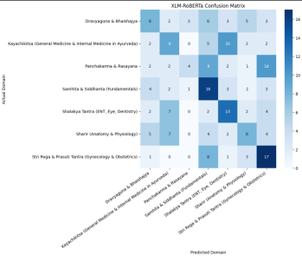Figure 12. XLM-RoBERTa Confusion Matrix
Shows correct and incorrect predictions across the Ayurvedic domains.
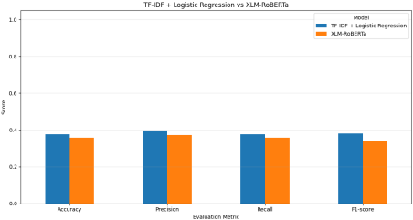Figure 13. TF-IDF + Logistic Regression vs XLM-RoBERTa Performance
Compares Accuracy, Precision, Recall and F1-score between the baseline and proposed model.
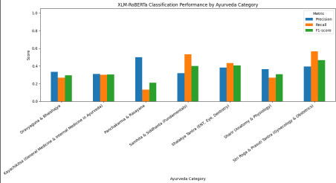Figure 14. XLM-RoBERTa Per-Class Performance
Compares Precision, Recall and F1-score across individual Ayurvedic categories.
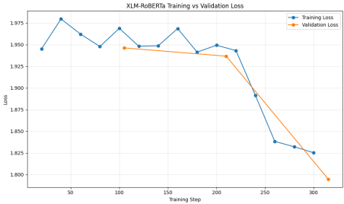Figure 15. XLM-RoBERTa Training vs Validation Loss
Shows model learning behaviour during training and helps identify potential overfitting.
Figure 16. XLM-RoBERTa Prediction Confidence Distribution
Shows the confidence distribution of the model's predictions on the test set.
Ks Arjun - The domain-specific SanskritBERT model was tested through the use of training and validation losses, tokenization, and masked-token prediction. The test findings reveal that there was improvement in the performance of the model after domain adaptation in the Ayurvedic Sanskrit dataset.
Figure 17: Validation Loss Before and After Domain Adaptation
The validation loss decreases from 13.2384 for the base SanskritBERT model to 1.2228 after domain adaptation. Figure 18: Training and Validation Loss During Domain Adaptation
The training and validation losses decrease throughout domain-adaptive pretraining, indicating that SanskritBERT progressively adapts to the HingAyur Ayurvedic Sanskrit corpus. The decreasing validation loss also indicates improved performance on unseen validation data.
Figure 19: Perplexity Before and After Domain Adaptation
The reduction from 561,518.50 to 3.40 indicates that domain adaptation substantially improves the model's ability to model Ayurvedic Sanskrit text.
Figure 20: Masked Token Prediction Accuracy Before and After Domain Adaptation
Masked-token prediction accuracy is used to evaluate the model's ability to recover missing tokens from Ayurvedic Sanskrit text.
Figure 21: Masked Token Prediction Confidence Before and After Domain Adaptation
The average probability assigned to the correct masked token is compared between the base and domain-adapted models.
2.7 Discussion
Tanmay Saxena- From the findings, it is evident that there is a disparity in the performance of the pre-trained Western biomedical named entity recognizer within the two contexts, as the performance in terms of detection is much better in the biomedical domain compared to that in English translation of Ayurvedic text. The poor performance in detecting Ayurvedic entities implies that Ayurvedic terminology is less adequately modeled by the system.
Saatvik Madan- Comparing the Results Between TF-IDF+Logistic Regression vs. XLM-RoBERTa on Hindi Ayurveda Classification. It can be seen from Figure 13 that the baseline method has produced a better Accuracy score (37.62%) and F1 score (38.02%) compared to XLM-RoBERTa (35.71% and 34.17%, respectively). Figures 4 and 6 represent the mistakes made in classification and per-class evaluation, whereas Figures 7 and 8 depict loss and confidence scores of the models. Generally speaking, the hypothesis was not proven correct.
Ks Arjun - From these findings, one can see that the application of domain adaptation made SanskritBERT better at processing Ayurvedic Sanskrit language. While training loss went down from 5.9067 to 2.3816, validation loss dropped from 2.5678 to 2.1890 during three epochs. Perplexity was significantly reduced, and so was masked-token prediction accuracy and confidence in predictions, which demonstrates that exposure to HIngAyur data set contributed to learning a relevant vocabulary and syntax.
2.8 Conclusion
This work looked into various NLP methods that could be used to process Ayurvedic knowledge from texts in English, Hindi, and Sanskrit languages. Tanmay conducted experiments on using a pre-trained biomedical NER model on English Ayurvedic text, Saatvik looked into the task of classifying Hindi questions related to Ayurveda using XLM-RoBERTa with a TF-IDF + Logistic Regression baseline, while Arjun concentrated on the domain adaptation of Sanskrit language models for Ayurvedic Sanskrit text using the HingAyur dataset. These works illustrate how NER, text classification, and domain adaptation could help to solve various problems in Ayurvedic NLP tasks.
2.9 References
Tanmay Saxena
1. Gita. (n.d.). Datasets. GitHub. Gita/Datasets
2. Neumann, M., King, D., Beltagy, I., & Ammar, W. (2019). ScispaCy: Fast and robust models for biomedical natural language processing. Proceedings of the 18th BioNLP Workshop and Shared Task, 319–327.
3. Li, J., Sun, Y., Johnson, R. J., Sciaky, D., Wei, C.-H., Leaman, R., Davis, A. P., Mattingly, C. J., Wiegers, T. C., & Lu, Z. (2016). BioCreative V CDR task corpus: A resource for chemical disease relation extraction. Database, 2016, baw068.
Saatvik Madan
1. BharatGen. (2025). BhashaBench-Ayur. Hugging Face. BhashaBench-Ayur corpus 2. Conneau, A., Khandelwal, K., Goyal, N., Chaudhary, V., Wenzek, G., Guzmán, F., Grave, E., Ott, M., Zettlemoyer, L., & Stoyanov, V. (2020). Unsupervised cross-lingual representation learning at scale. Proceedings of the 58th Annual Meeting of the Association for Computational Linguistics, 8440–8451.
Ks Arjun
1. Wujastyk, D. (Ed.). (2011). Carakasaṃhitā: A SARIT edition. SARIT: Search and Retrieval of Indic Texts. https://sarit.indology.info/carakasamhita.xml?view=div 2. Yamashita, T., Muroya, Y., Yamanaka, Y., & Madhu K. P. (2011). Machine-readable version of Carakasaṃhitā. In D. Wujastyk (Ed.), SARIT: Search and Retrieval of Indic Texts. https://sarit.indology.info/carakasamhita.xml?view=div
3. Saxena, T., Sharma, S., & Lata, K. (2026). SanskritBERT: A Light Transformer Model for Sanskrit. Hugging Face. https://huggingface.co/tanuj437/SanskritBERT

